21071A67C2_DSB_DAA

1)Given a row wise sorted matrix of size **R*C** where R and C are always **odd**, find the median of the matrix.

# Test Case 1:

**MEDIAN=5**

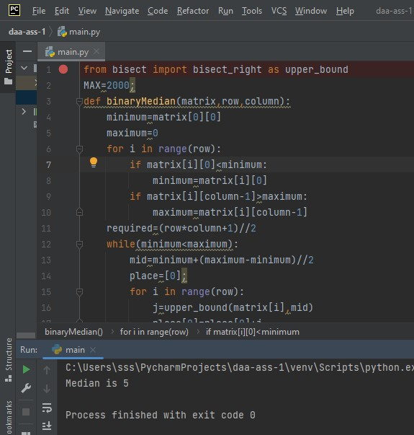

**Test Case 2:**

**Input:**R = 3, C = 1M = [[1], [2], [3]]**Output:** 2**Explanation**: Sorting matrix elements gives us {1,2,3}. Hence, 2 is median.

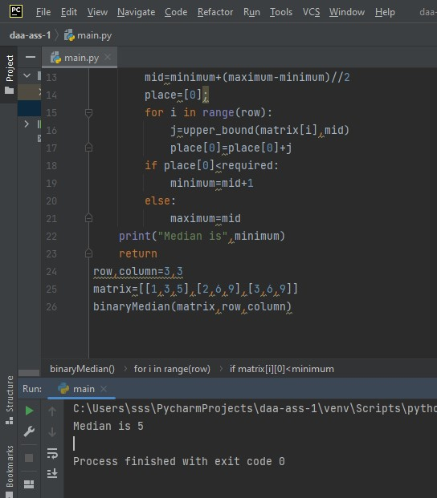

2) 2) 2. Given the arrival and departure times of all trains that reach a railway station, the task is to find the minimum number of platforms required for the railway station so that no train waits. We are given two arrays that represent the arrival and departure times of trains that stop.

# Test case 1

***Input:*** *arr[] = {9:00, 9:40, 9:50, 11:00, 15:00, 18:00}, dep[] = {9:10, 12:00, 11:20, 11:30, 19:00, 20:00}* ***Output:*** *3*

***Explanation:*** *There are at-most three trains at a time (time between 9:40 to 12:00)*

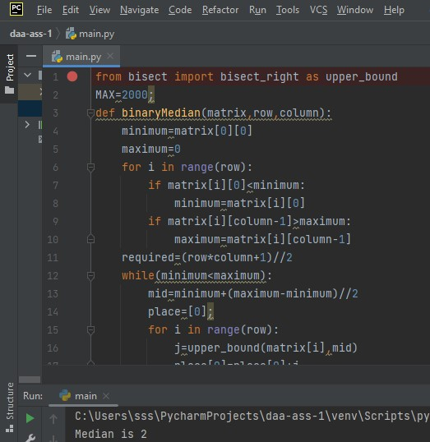

# Test case 2

***Input:*** *arr[] = {9:00, 9:40}, dep[] = {9:10, 12:00}*

***Output:*** *1*

